**CHAPTER 1**

**INTRODUCTION**

This project is all about Simple & Smart Electronic Voting Machine Using Arduino. The basic idea of this project is to create an electronic voting machine that will help to eradicate defrauding of the manual voting systems and prior versions of electronic voting.

In this project, i.e, Smart Electronic Voting Machine Using Arduino, we have used four pushbuttons for four different candidates who are taking part in the election. We can increase the number of the candidate as per requirement. When any voter press any of four buttons then respecting voting value will increment by one each time. After the whole voting process, the fifth button is used as result button can be pressed to display the result. We have an LCD to display the voting for the satisfaction of the voters. Finally, the results can be calculated automatically simply by pressing the result button.

These devices have been praised for their simple design, ease of use and reliability. However, it has been found that EVMs are not tamper proof and are easily hacked. Moreover this attacks, hardware as well as software, go without any detection but are quite simple to implement. This made us to bring forth a system that is secure, transparent, reliable as well as easy to use for the citizens.

**CHAPTER 2**

**COMPONENTS REQUIRED**

1. Arduino UNO (1)
2. 16x2 Lcd display (1)
3. 10k ohm potentiometer (1)
4. Push button switches (5)
5. 220 ohm resistors (2)
6. 5mm LED (2)
7. Breadboard (2)
8. Jumper wires

**COMPONENT DESCRIPTION**

1. **ARDUINO UNO**:

A microcontroller that can connect to electrical components and program them using software. The Arduino Uno has a series of black pins that connect to electrical components via wires. The pins have different functions depending on what they’re labelled: a) power pins, b) digital pins, and c) Analog pins.

a. The power pins provide power and ground to the breadboard. The 3V and the 5V pin are 3 volt and 5 volt power supplies, respectively. The GND pin is the ground. This is where the circuit ends. There are two GND pins on the Arduino Uno. One is with the power pins and the other is with the digital pins. We will be using the GND pin near the digital pins.

b. Digital pins can only have two states, ON or OFF. When a digital pin is on (HIGH or 1), it’s supplying power. When it’s off (LOW or 0), it’s not supplying power. We can control whether the pin is on or off using software. The digital pins are labelled 0 - 13. They can act either as an input, receive sensor information, or output, send instructions or power to a component, in the circuit. We will be using the digital pins as outputs in this project. They will be supplying the LED with power based on our software instructions.

c. Analog pins can have a variety of values beyond just off or on. They can be any fraction between 0 and 1. The Analog pins are labelled A0 - A5.

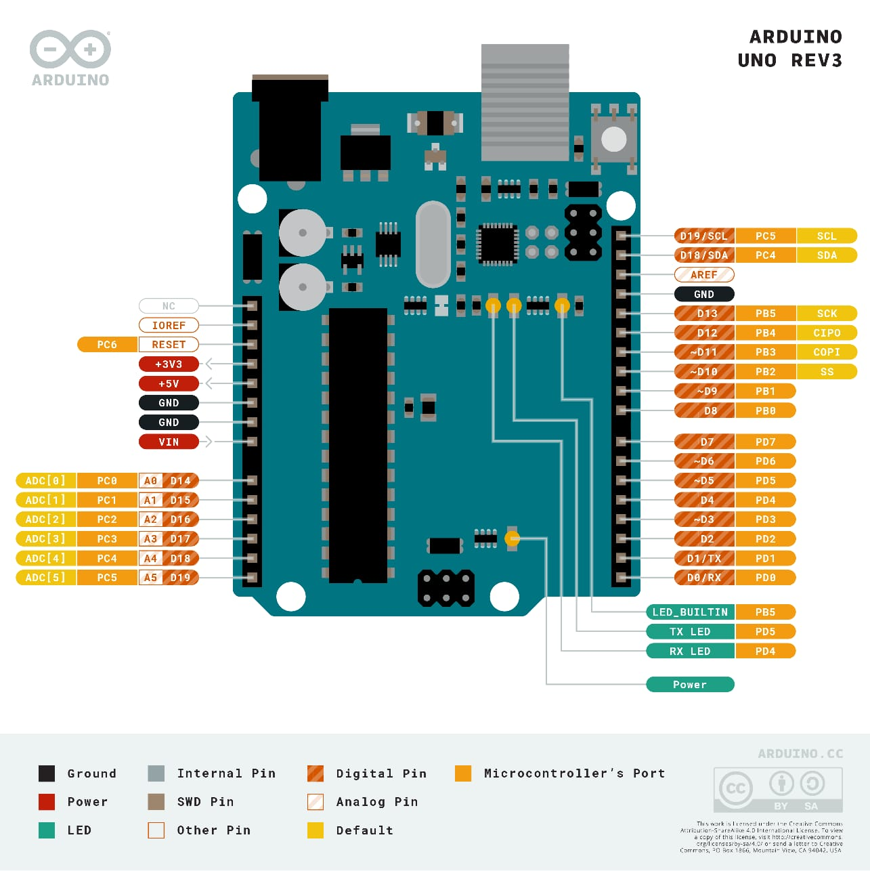

1. **16x2 LCD DISPLAY:**

A 16×2 LCD has two [registers](https://www.elprocus.com/know-about-types-of-registers-in-8051-microcontroller/) like data register and command register. The RS (register select) is mainly used to change from one register to another. When the register set is ‘0’, then it is known as command register. Similarly, when the register set is ‘1’, then it is known as data register.

**Command Register:**

The main function of the command register is to store the instructions of command which are given to the display. So that predefined tasks can be performed such as clearing the display, initializing, set the cursor place, and display control. Here commands processing can occur within the register.

**Data Register:**

The main function of the data register is to store the information which is to be exhibited on the LCD screen. Here, the ASCII value of the character is the information which is to be exhibited on the screen of LCD. Whenever we send the information to LCD, it transmits to the data register, and then the process will be starting there. When register set =1, then the data register will be selected.

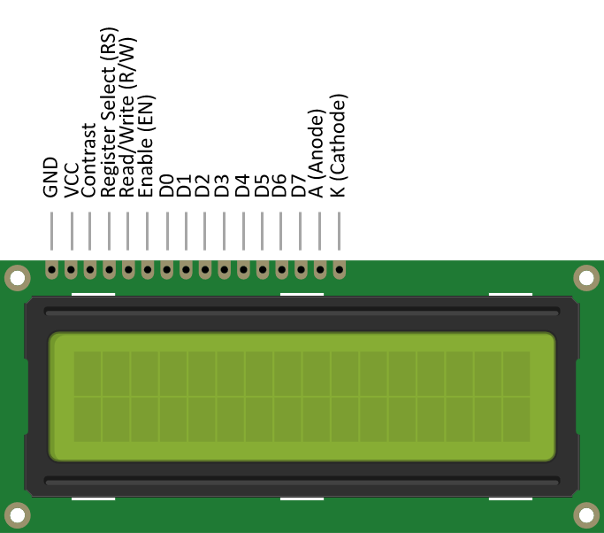

Fig.1 16x2 LCD display

**Features of LCD16x2**

The features of this LCD mainly include the following.

* The operating voltage of this LCD is 4.7V-5.3V
* It includes two rows where each row can produce 16-characters.
* The utilization of current is 1mA with no backlight
* Every character can be built with a 5×8 Pixel box
* The alphanumeric LCDs alphabets & numbers
* These are obtainable in Blue & Green Backlight
* It displays a few custom generated characters

1. **RESISTORS :**

All material have some type of opposition to the current flow. This opposition is called resistance. The resistance of a material is determined by the number of free electrons in the material. There are various type of resistor available such as carbon film, carbon composition, filament resistor and many more which can be used in an electronics or electrical circuit to determine the resistance.



Resistance of circuit depends upon p, L and A with the following equation.

R = p*(L/A). Here, we are using a 220Ω resistors.

Size, and position of leads (or terminals) are relevant to equipment designer; resistor must be physically large enough not to overheat when dissipating their power.

1. **10kΩ POTENTIOMETER**

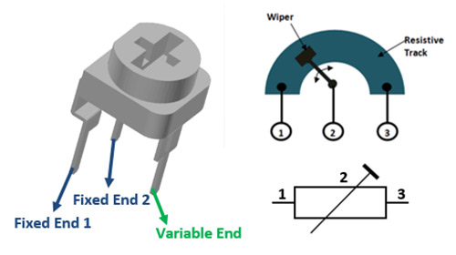

Fig.2 10kΩ potentiometer

Potentiometers also known as **POT**, are nothing but **variable resistors**. They can provide a variable resistance by simply varying the knob on top of its head. It can be classified based on two main parameters. One is their **Resistance (R-ohms)**itself and the other is its **Power (P-Watts)** rating.

**Potentiometer Pin Configuration**

|  |  |  |
| --- | --- | --- |
| **Pin No.** | **Pin Name** | **Description** |
| 1 | Fixed End | This end is connected to one end of the resistive track |
| 2 | Variable End | This end is connected to the wiper, to provide variable voltage |
| 3 | Fixed End | This end is connected to another end of the resistive track |

1. **Light Emitting Diode (LED):**

An LED or Light Emitting Diode is a simple PN junction diode, made of material with larger energy barrier. As the supply is given to the LED junction, the electrons move from the valence band to the conduction band. When the electron looses energy and falls back to its original state, a photon is emitted. This emitted light is in the frequency band of the visible frequency range of light.

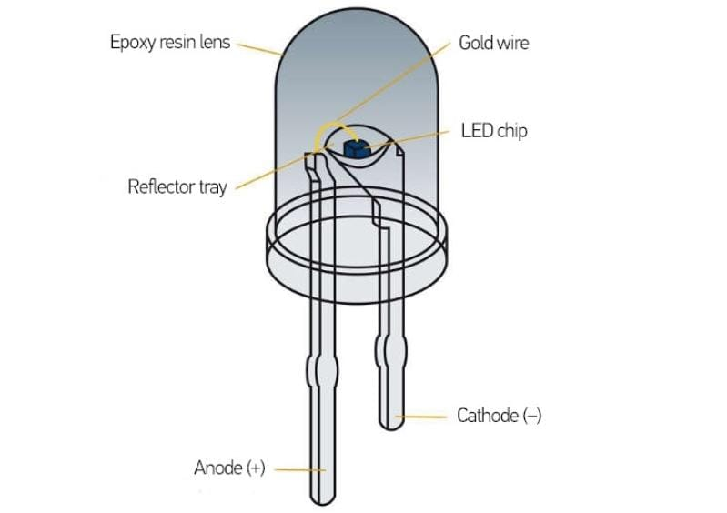

And we also using the Bread board with pushbuttons with some jumper wires. Here we can also use of 9 volts battery or any power source.

**CHAPTER 3**

**CIRCUIT DIAGRAM**

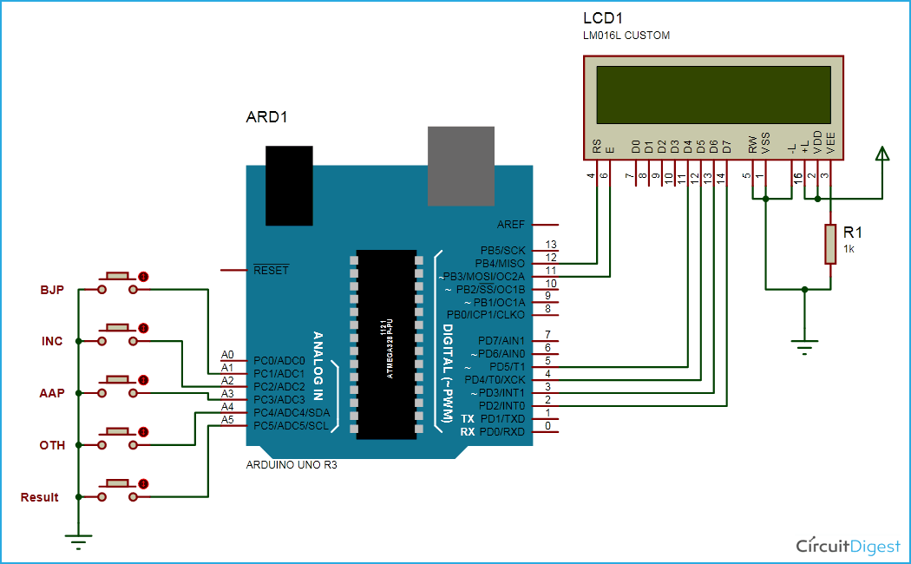

CIRCUIT DIAGRAM OF ELECTRONIC VOTING MACHINE

**Step by step procedure:**

1. First, connect the power supply to the breadboard and Arduino. You can use a 9V battery or a USB cable to power the Arduino.
2. Next, connect the LCD screen to the breadboard. Connect the VSS pin to the ground rail on the breadboard. Connect the VDD pin to the +5V rail on the breadboard. Connect the VO pin to the wiper pin of the 10k potentiometer. Connect the RS pin to pin 12 on the Arduino. Connect the RW pin to ground on the breadboard. Connect the E pin to pin 11 on the Arduino. Connect the D4-D7 pins to pins 5-2 on the Arduino, respectively.
3. Connect the 10k potentiometer to the breadboard. Connect one end of the potentiometer to ground on the breadboard. Connect the other end of the potentiometer to the +5V rail on the breadboard. Connect the wiper pin of the potentiometer to the VO pin on the LCD screen.
4. Connect the push buttons to the breadboard. Connect one side of each push button to a digital pin on the Arduino (e.g. pins 7-11). Connect the other side of each push button to ground on the breadboard. Place a 220ohm resistor between each digital pin and the corresponding push button to protect the pin.
5. Connect the green LED to the breadboard. Connect the anode (longer leg) of the LED to a digital pin on the Arduino (e.g. pin 6). Connect the cathode (shorter leg) of the LED to a 220ohm resistor. Connect the other end of the resistor to ground on the breadboard.
6. Connect the red LED to the breadboard. Connect the anode (longer leg) of the LED to a digital pin on the Arduino (e.g. pin 13). Connect the cathode (shorter leg) of the LED to a 220ohm resistor. Connect the other end of the resistor to ground on the breadboard.
7. Finally, connect the Arduino to the breadboard using jumper wires. Connect the GND pin on the Arduino to the ground rail on the breadboard. Connect the +5V pin on the Arduino to the +5V rail on the breadboard. Connect the digital pins used for the push buttons and LEDs to the corresponding pins on the breadboard.
8. Now add the Arduino code written for the Electronic Voting Machine(EVM) using the Arduino software.

**CHAPTER 4**

**WORKING**

* In this project, i.e, Smart Electronic Voting Machine Using Arduino, we have used four pushbuttons for four different candidates who are taking part in the election. We can increase the number of the candidate as per requirement.
* Four push buttons (connected to pins 7-10) are used to register votes for the candidates. A green LED (connected to pin 6) is used to indicate when a vote has been cast. It will blink briefly after a button has been pressed.
* A red LED (connected to pin 13) is used to indicate when the results are being displayed. It will blink briefly before the results are shown. The LCD screen (connected to pins 2-5 and 11-12) is used to display the total number of votes cast for each candidate.
* The program waits for a button press, then increments the vote count for the corresponding candidate and blinks the green LED.The program then updates the LCD screen to show the updated vote counts for each candidate.
* The program can be instructed to display the results by pressing a fifth button (connected to an arbitrary pin) which causes the red LED to blink and the total number of votes for each candidate to be displayed on the LCD screen.

**CHAPTER 5**

**ADVANTAGES AND DISADVANTAGES**

ADVANTAGES:

There are several advantages of using an electronic voting machine (EVM) with Arduino and an LCD display:

1. Accuracy: An EVM with an LCD display ensures accurate counting of votes. It eliminates the possibility of human error in counting and reduces the time required for the counting process.
2. Easy to use: The use of push buttons and an LCD screen makes it easy for voters to use the EVM. The LCD screen can display instructions for the voters, making it user-friendly.
3. Cost-effective: The use of Arduino and an LCD display is relatively cost-effective compared to other electronic voting machines. This makes it an affordable option for small-scale elections.
4. Portability: An EVM with Arduino and an LCD display is compact and portable, making it easy to transport to different locations for voting.
5. Flexibility: The use of Arduino makes it possible to customize the EVM to suit different voting systems. It can be programmed to handle different numbers of candidates, voting rules, and display formats.
6. Security: Arduino-based EVMs can be designed with security features such as password protection and encryption to prevent unauthorized access or tampering of the voting data. The use of push buttons instead of touch screens also eliminates the risk of hacking or manipulation.

DISADVANTAGES:

Here are some potential disadvantages of using an electronic voting machine (EVM) with Arduino and an LCD display:

1. Limited capacity: The use of Arduino and an LCD display may limit the capacity of the EVM in terms of the number of candidates or voters it can handle. This can be a challenge for larger elections where a larger number of candidates and voters need to be accommodated.
2. Vulnerability to malfunction: The use of electronic components in the EVM increases the risk of technical malfunctions that can disrupt the voting process. Malfunctions can also result in inaccurate vote counts, which can undermine the integrity of the election.
3. Dependence on electricity: EVMs require a stable source of electricity to operate, which can be a challenge in areas with unreliable or inadequate power supply. This can result in delays or interruptions in the voting process.
4. Accessibility: The use of an LCD display may pose challenges for voters with visual impairments. The display may also be difficult to read in bright sunlight or poorly lit areas.
5. Lack of transparency: The use of technology in the voting process can create a perception of lack of transparency, making it difficult for voters to verify that their votes have been accurately recorded and counted.

It's worth noting that many of these potential disadvantages can be mitigated with proper design and testing of the EVM, as well as with adequate training and support for election officials and voters.

**CHAPTER 6**

**APPLICATIONS**

Here are some potential applications of an electronic voting machine (EVM) using Arduino and an LCD display:

1. Local and regional elections: EVMs can be used in local and regional elections, such as municipal or county-level elections. They can be designed to handle a moderate number of candidates and voters, and can be customized to suit local voting rules and regulations.
2. Student government elections: EVMs can be used in student government elections in schools and colleges. They can be a more efficient and accurate alternative to manual voting methods, and can help to promote transparency and fairness in the election process.
3. Small-scale elections: EVMs can be a cost-effective option for small-scale elections, such as those conducted by community groups, clubs, or non-profit organizations.
4. Polls and surveys: EVMs can also be used for conducting polls and surveys, such as market research or public opinion surveys.
5. Experimental research: EVMs can be used in experimental research to test different voting systems and to study voter behaviour and decision-making.
6. Any situation where accurate and efficient vote counting is needed: EVMs can be used in any situation where accurate and efficient vote counting is needed, including corporate elections, shareholder meetings, and other organizational elections.

It's worth noting that the specific applications of EVMs will depend on the design and features of the machine, as well as the specific requirements of the voting situation.

**CHAPTER 7**

**FUTURE SCOPE**

Here are some potential future scopes for electronic voting machines (EVMs) using Arduino and LCD displays:

* Integration with blockchain technology: EVMs can be integrated with blockchain technology to create a secure and transparent voting system. Blockchain can provide an immutable ledger of votes, which can help to prevent tampering and ensure transparency in the voting process.
* Artificial intelligence and machine learning: EVMs can be integrated with artificial intelligence (AI) and machine learning (ML) algorithms to improve the accuracy and efficiency of the vote counting process. AI and ML can help to detect and correct errors in real-time, and can also help to optimize the voting process.
* Wireless and mobile voting: EVMs can be designed to work with wireless and mobile networks, enabling remote voting and increasing accessibility for voters. This can be especially useful in areas with limited infrastructure or in situations where voters are unable to physically travel to polling stations.
* User interfaces and accessibility: EVMs can be designed with user interfaces that are more accessible to a wider range of voters, including those with visual or physical impairments. This can help to promote greater participation in the voting process and can improve the overall integrity of the election.
* Improved security: EVMs can be designed with improved security features, including advanced encryption and multi-factor authentication, to prevent unauthorized access or tampering of the voting data.
* Open-source development: EVMs can be developed using open-source software and hardware, making it easier for developers to create and customize voting machines for specific requirements. This can help to promote innovation and collaboration in the development of new EVMs.

**CHAPTER 8**

**CONCLUSION**

In conclusion, electronic voting machines (EVMs) using Arduino and LCD displays have the potential to improve the accuracy, efficiency, and transparency of the voting process. They can be used in a variety of applications, from local and regional elections to student government elections and small-scale polls and surveys.

However, there are also potential drawbacks to using EVMs, including limitations in capacity, vulnerability to malfunction, and dependence on electricity. To address these challenges, it is important to design and test EVMs thoroughly, and to provide adequate training and support to election officials and voters.

Looking to the future, there are exciting potential developments in the field of EVMs, such as integration with blockchain technology, artificial intelligence and machine learning, wireless and mobile voting, improved security, and open-source development. These developments have the potential to further improve the accuracy, security, and accessibility of EVMs, and to ensure that the voting process is transparent and fair for all.

**REFERENCES**

[1] Aranganadhan. N. S, M. DhineshKumar, Praveenkumar. DSanthosh.A, “Embedded System based Voting Machine System using Wireless Technology”, International journal of innovative research in electrical instrumentation and control engineering, Vol. 4, Issue 2,2016,pp.127-130.

[2] Deepak Rasaily Jigmee Sherpa, Yashal Dorzee Lepcha, “Design of Electronic Voting Machine using Microcontroller”, International Journal of Engineering Trends and Technology, ISSN: 2231,Vol-32 issue 5,2016,pp.277-278.

[3] Deepika, Iswarya, Rathna Prabha, Trini Xavier, “A Survey on E-Voting System Using Arduino Software” International Journal of Advanced Research in Electrical, Electronics and Instrumentation Engineering (An ISO 3297: 2007 Certified Organization) Vol. 5, Issue 2, February 2016, pp.687-690.

[4] Diponkar Paul, Sobuj Kumar Ray, “A Preview on Microcontroller Based Electronic Voting Machine”, International Journal of Information and Electronics Engineering, Vol. 3,2013, pp.185-190.

[5] Mr. Soumen Ghosh, “Development of Microcontroller Based Electronic Voting Machine” IOSR Journal of Electrical and Electronics Engineering ,e-ISSN: 2278- 1676,p-ISSN: 2320-3331, Vol. 9, Issue 2 ,2014,pp.1-3